Bunker Gear Dryer 1
Project plans by: Linda Mentz
Beneficiary: Gainesville Fire Rescue
Contents

Introduction 2
Parts Needed 3
Tools Needed 4
Base 5
Hangers 7
Extra Gear Rack 10
Top Bar 13
Leg 2 14
Shoe 15
Blower Stand 17
Putting it all together 19

Please note that this was the less successful design. Consider alterations, or you may find brittle joints and air blowers self-destructing in a matter of months.

Introduction
“Bunker gear is the protective clothing that firefighters wear into Immediately Dangerous to Life and Health (IDLH) environments such as fires, hazardous materials incidents, and vehicle extractions. After use in an IDLH environment, the gear must be immediately cleaned to remove carcinogens before it may be used again. The need for these dryers was identified as part of GFR’s cancer prevention program.”
-Interim Fire Chief JoAnne Rice,
Gainesville Fire and Rescue
Gainesville, Fl

- Building a bunker gear dryer is a great project to help the first responders in our communities. It is a fun Eagle project that can be accomplished in a month or so.
- If you are a scout looking to recruit help to work on this, please keep in mind some Scouts BSA safety guidelines:
  - You must be at least 14 to use an electric screwdriver
  - You must be 18 or older to use a jig saw, circular saw, or chop saw
- Part of an Eagle project is making sure you have the right safety equipment and tools to do a project safely. All 1” pieces of PVC can be cut be younger scouts with handsaws and miter boxes, but 4” pipe cuts will need to be made by adults with chop saws.
- The airflow out of the small holes in the hangers averages at about 5.5 meters per second.
- The cost of materials to build such a unit is about $500 (I calculated spending $493.28 on the materials). This does not include the price of the blower used in the dryer shown, the FJ2-30C. This also does not include the cost of tools (saws, drills, sandpaper, etc).
- Different blowers can be used with minimal adjustment to assembly. The FJ2-30C has a 4 inch output.
- The bunker gear dryer described below is based on pictures of similar dryers from Harrison Fire Department and a Continental Expressdry Product.

Parts Needed
Base
Part Number
The base described can be pushed on wheels with ease. The sizes of the holes in the metal plates on the wheels are often inconsistent. Check to make sure that the bolt can go through the plate.
2 x 4 lumber | 4
15/32” x 4’ x 8’ sheet of plywood, pine | 1
3” swivel wheel with break | 4
5/16th* 1-½ lag screws | 16
3” deck screws, 5 lbs | 1
Polyurethane | 1 qt
Primer | 1 gal
Interior Paint (any color, red on example) | 1 gal

Hangers
Part Number
1” PVC valve, nonthreaded | 4
1” PVC cap | 16
1” 45-degree elbow joint | 8
1” tee joint | 12
1” x 10’ schedule 40 PVC pipe | 4
All parts in yellow are the total components of the four hangers. Each individual hanger will have the number of total parts divided by 4. (ie 4 caps per hanger)
Extra Gear Rack
Part Number
The extra gear rack is not a necessary addition. If you chose to omit it, purchase one less 4” x 1” reducing tee.
1” PVC end caps | 8
1” PVC cross joints | 4
1” PVC valve, nonthreaded | 1
1” 45-degree elbow joint | 8
1” x 10’ pipe | 1
1” 90-degree elbow joint | 1
1” PVC plug (plugs are flat on bottom) | 1

Central Tube
The central tube is the combination of three separately assembly pieces: the top bar, leg 1, and the blower stand (parts not included in “Central Tube” list).
Part Number
4” x 10’ DWV PVC pipe | 2
4” 90-degree elbow joint | 2
4” x 1” PVC reducing tee joint | 5

Blower Stand
Part Number
In the blower stand, all parts with “rubber” are included to decrease the contact between the plastic and wood/metal. The goal is to reduce friction as well as noise.
2” x 4” lumber | 1
2” x 8” lumber | 1
3/8” galvanized washer | 8
3/8” rubber washer | 4
3/8” nuts | 4
3/8” x 3 ½” bolts | 4
3/8” Galvanized lock washer | 4
1/8 x 5 x 5 strip of rubber | 1
4” flexible coupling | 1

Other materials needed:
You won’t need nearly 5 lbs of deck screws to finish this project, but it is a standard size of container to purchase them in. Giant zip ties used in final assembly.
Part Number
8 oz. jar of PVC glue | 2
18 oz container of wood glue | 1
2” deck screws, 5 lbs | 1
Giant zip ties | 8

Tools Needed
To cut:
- Jig saw
- Circular saw
- Hand saw and miter box
- Chop saw
To drill:
- set of drills
- electric screwdriver
- T25 drill bit
- Socket wrench set
To support:
- 2 sawhorses
Safety Gear
- Earmuffs
- Safety glasses
- 4 clamps
To measure
- Tape measure
- T square
- Pencil/marker
Other:
- Paintbrushes
- Rag on a stick (to spread polyurethane)
- Sander/ sandpaper
- Hammer, rubber mallet
- Pencil
- Painters tape

Base
Wood needed:
Type Length Number
2 x 4 | 33” | 3
2 x 4 | 8’ | 2
2 x 4 | 7” | 4
4 x 8 sheet of plywood, pine | 3 by 8 (cut off one foot of width) | 1

Parts needed:
Part Number
Deck screws (3”) | About 50
Castor wheel (3” w/ swivel) | 4
Lag screws (5/16th* 1-½) | 16
Wood glue | 18 oz
Primer | 1 gallon
Paint | 1 gallon
Polyurethane | 1 qt

Basic Instructions
- Place plywood on sawhorses. Cut 4x8 sheet of plywood to 3x8 using a handheld circular saw.
- Flip plywood to side where curve of wood is pointing down
- Cut 2x4s to correct lengths. Put wood glue on width of 8’ 2x4s, put glue down 8’ sides of the plywood
- Line up edge of 2x4s with wood glue on plywood. If 2x4s are bowing, put bulging side out. Clamp both in place (4 clamps used).
- Flip over plywood. Starting at one end, screw in boards. Screws should be about 10 inches apart. Try to push in the bulging middle while screwing (if applicable).
- You should have a shallow open box missing two sides and a top. For the missing sides, Use the 33” 2 x 4s. This is a ROUGH ESTIMATE! Wood should be cut to fit the width between the 8’ pieces. Glue and screw using the same strategy as the 8’ pieces. Put 3 screws in the side of each corner, connecting the 8’ pieces to the 33” pieces.
- Add another 33” piece in the middle of the box for strength. You can find the middle of the box by drawing 2 lines from one corner to the other, and seeing where they intersect. Glue and screw.
- Add the 7” 2 x 4s to the corners. Glue and screw in from the side or bottom. This is to provide the corner area to install the castors.
- Place castors on corners. Mark with a pencil where bolts will be placed. Remove castors and predrill holes.
- Install castors. Lag screws will require a socket wrench on a drill.
- Tape up wheels to protect them from the paint. Flip over. Prime top (flat side, with heads of screws) and sides of the base. Wait for the primer to dry.
- Paint. This can be any color; the example is red and grey. Wait for paint to dry. Depending on what paint is used, two layers might be necessary.
- Once paint is dry, polyurethane the base. This is a liquid substance you can combine with water and wipe around with a rag. It prevents muddy footprints and makes the whole base last longer.

Hangers
Connectors needed:
Name Size Number
Tee | 1” | 3
45 degree elbow | 1” | 2
cap | 1” | 4

PVC pipe needed:
Length Diameter Number
2” | 1” | 5
10” | 1” | 2
30” | 1” | 2

Basic Instructions:
- Cut 1 stick of 10’ * 1” PVC pipe to the desired lengths. You will have extra. Sand PVC particles off if necessary (probably will be if cut with handsaw)
- Drill 2 equidistant holes in the 10” pieces (leaving room for the end cap) and 4 equidistant holes in the 30” pieces (leaving room for the end cap). The drill should go all the way through the pipe (you will drill three times, but have 6 holes). Drill should be 3/16 or similar.
- Connect the 3 tees with 2 pieces of 2” PVC pipe. The tees on the ends should be pointed down, while the tee in the middle should be pointed up.
- Attach the 45 degree elbows to the tees with 2 pieces of 2” PVC pipe (one each). Elbows should be facing down.
- Once you’re confident that you can assemble it correctly, take it apart and use PVC glue to reassemble it.
- Connect the two 10” pieces of PVC into the elbows. These are the “arms”. Glue into place.
- Connect the two 30” pieces of PVC into the two downward-facing tees. These are the “legs”. Glue into place.
- Drill two holes into each of the four end caps. Stick the end caps onto each of the arms and legs. Gluing is optional. Not gluing allows you to check airflow through the whole pipe to see if a single hole is blocked.
- To connect the hanger to the U-tube, attach one 2” piece, a valve (optional), and another 2” piece. Gluing the hangers to the U-tube before final assembly makes it more difficult to transport.
- Repeat. 4 (or more!) of the hangers can be included in the final design.

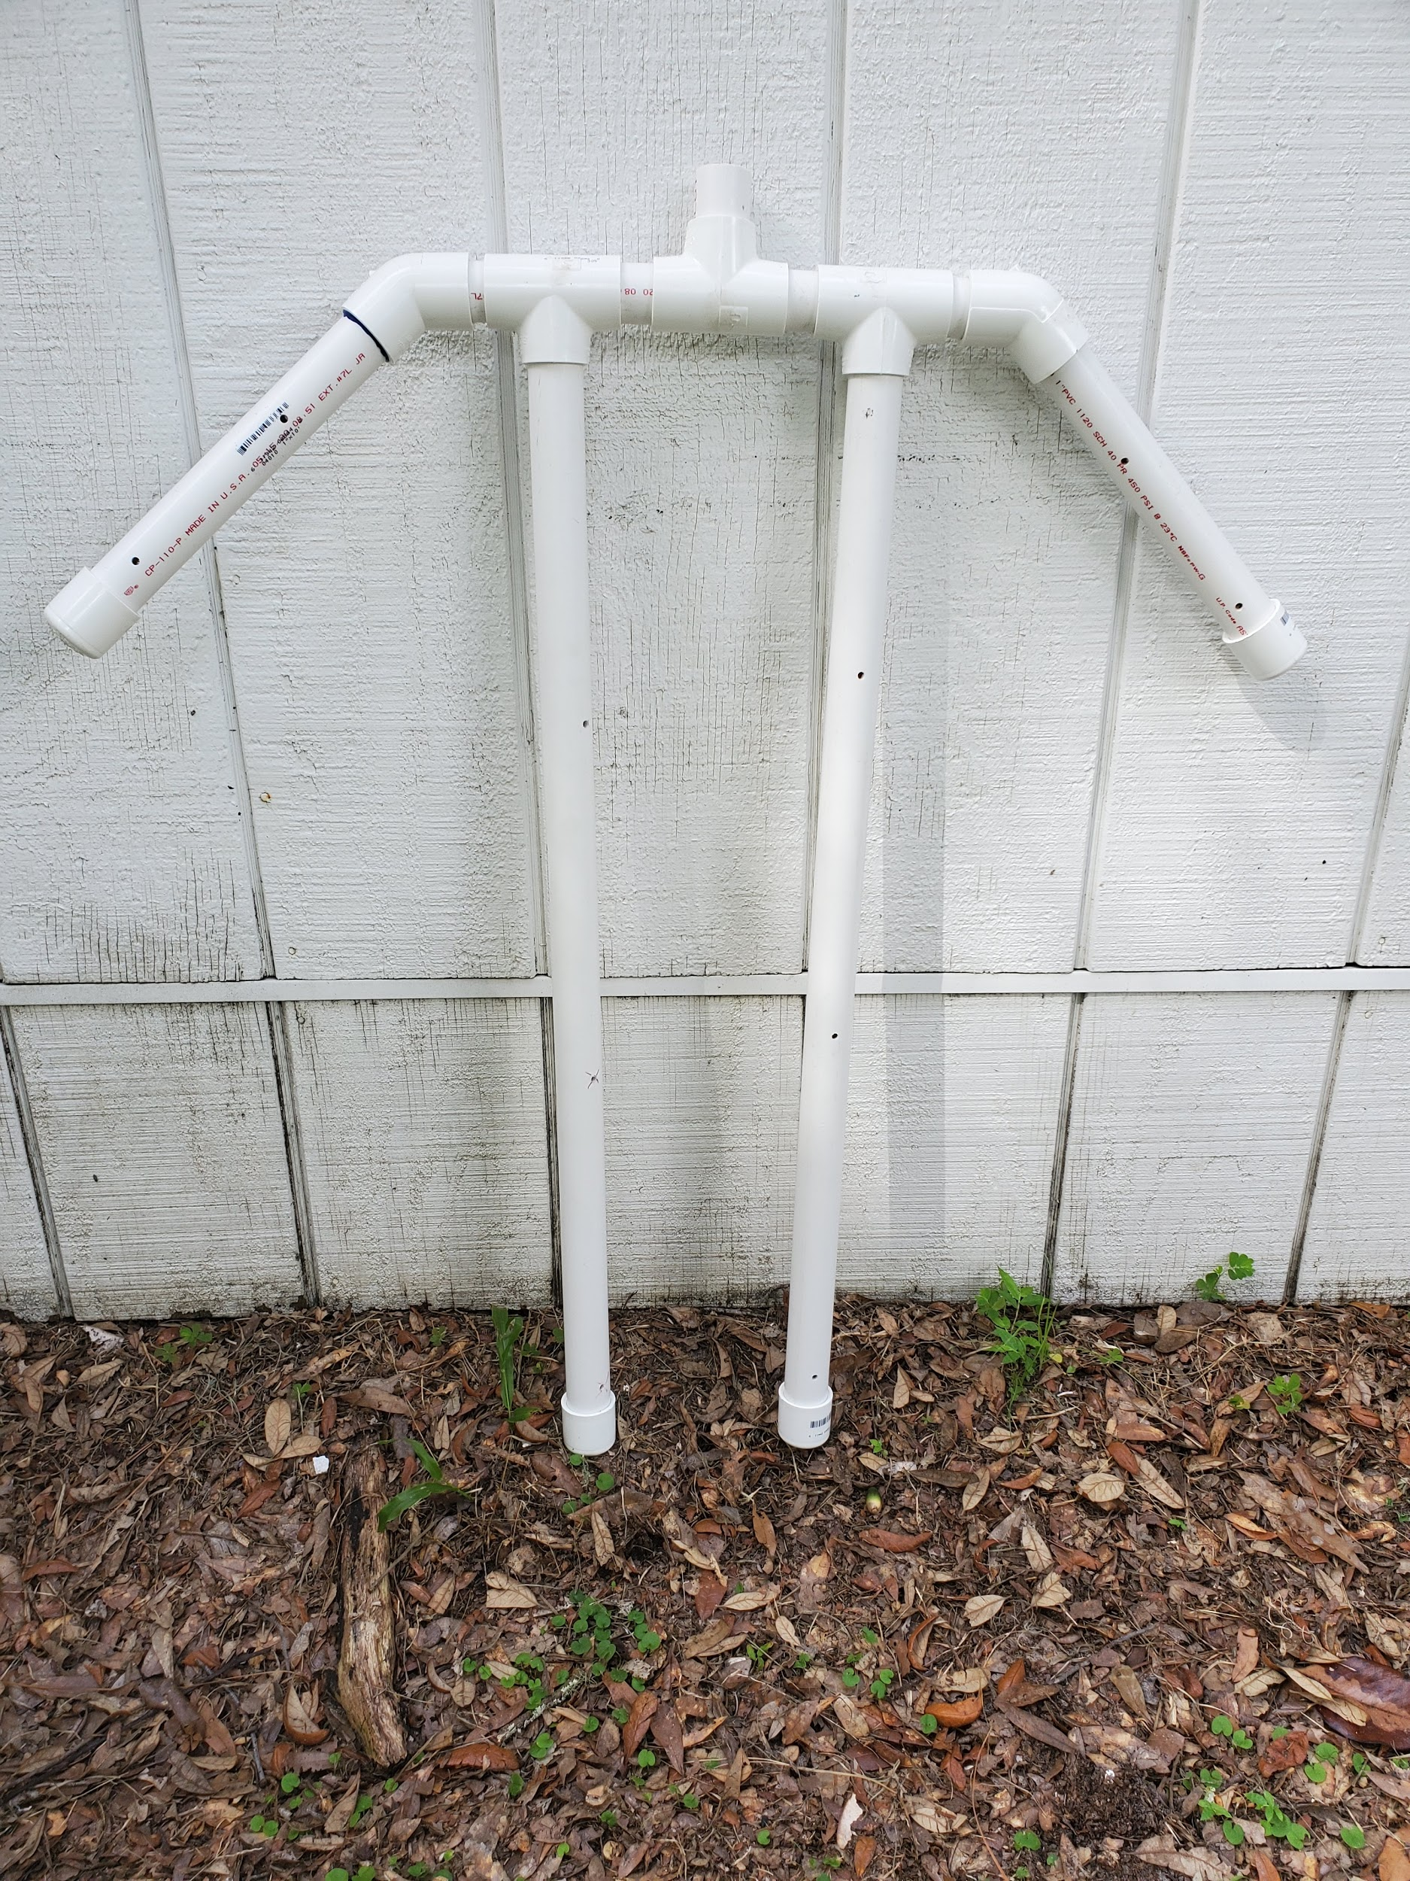

Extra Gear Rack
Connectors needed:
Name Size Number
45 degree elbow | 1” | 8
cap | 1” | 8
cross | 1” | 4
90 degree elbow | 1” | 1

PVC pipe needed:
Length Diameter Number
2” | 1” | 9
6” | 1” | 12

Basic Instructions:
- Cut desired lengths of PVC from a stick of 1” * 10’. Sand ends to get rid of shredded PVC.
- Connect crosses with 6” pieces going from top to bottom. Leave the lowest cross open on the bottom.
- Connect 2” pieces to the sides of each cross. Attach 45 degree elbows to 2” pieces, pointing up.
- Put the remaining eight 6” pieces in the 45 degree elbows.
- Cap each piece. If caps are glued into place, make sure to drill holes in the caps first! The caps in the example are not glued in place to make it easier to check airflow.
- Use the height of leg 2 (page 14) to determine the length of the piece of PVC at the bottom so the extra gear rack stands perfectly straight when connected with leg 2. Make sure to include the thickness of the end cap used in this measurement. You will probably want to wait to add the bottom of the gear rack until after assembling the whole central tube.
- Glue 90 degree elbow to the top piece of 6” PVC. Add valve if desired. Use two short pieces of 2” PVC and a valve to connect the extra gear rack to the 4” * 1” tee on leg 2.

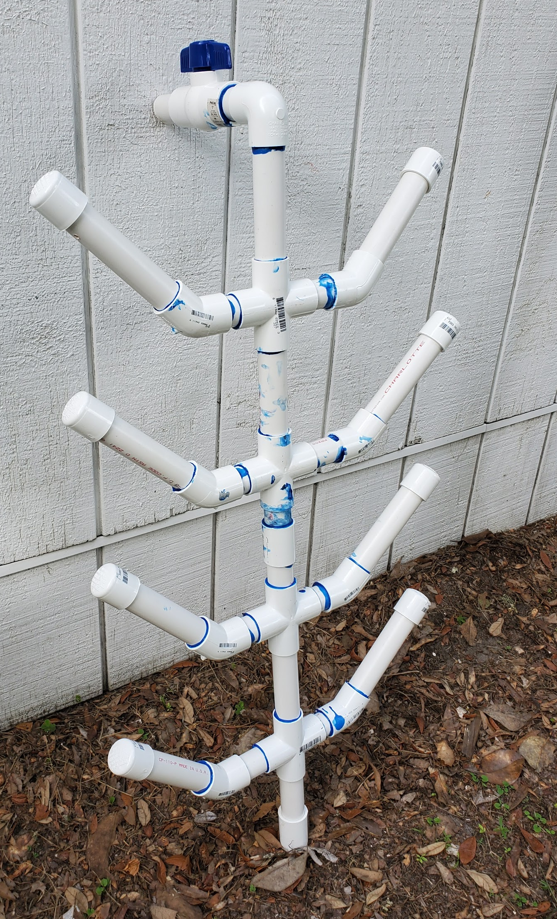

Top Bar
Connectors needed:
Name Size Number
Reducing Tees | 4” * 1” | 4
90 degree elbows | 4” | 2

PVC pipe needed
Length Diameter Number
10” | 4” | 5

Basic Instructions
- Cut PVC to needed length
- Connect reducing tees with the 10” pieces. Make sure 1” pieces are all lined up evenly with a level, this will make sure all your hangers are hanging straight down and decrease how much the pipe has to flex.
- Add 90 degree elbows. Again, glue them in pointing straight down, or even with reducing tees.
- When gluing, make sure each piece of PVC is completely pushed into the connectors.

Leg 2
Connectors needed:
Name Size Number
Reducing Tee | 4” * 1” | 1
Cap | 4” | 1

PVC pipe needed:
Length Diameter Number
3’ | 4” | 1
23” | 4” | 1

Basic Instructions
- Cut PVC pieces to the appropriate length. Leg 2 will determine the height of your structure (height of leg 2 + height of base= total height)
- Connect two pieces with the reducing tee. Add the cap to the end of the 3’ piece.
- Do not glue anything in this section until you are sure:
  - The height of leg 2 equals the height of the blower stand
  - Shoe fits 4” cap tightly (see Shoe instructions below!)
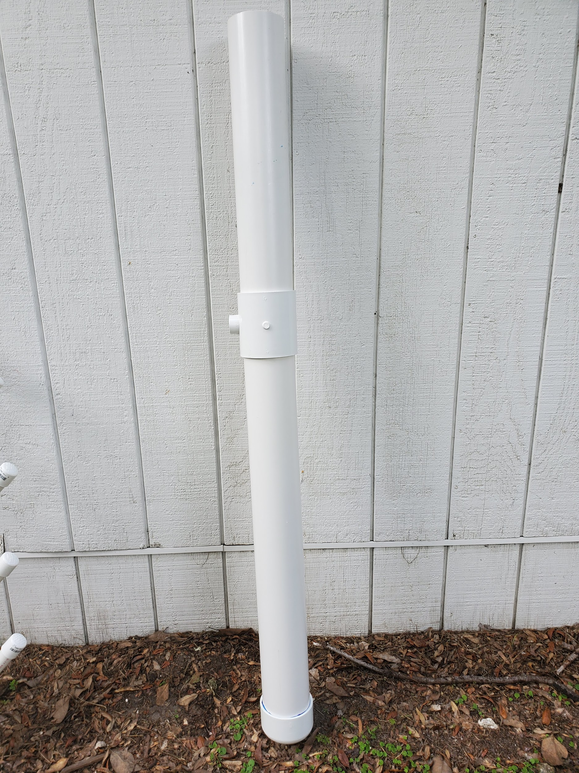

Shoe
*note: Parts for “shoe” piece not on materials list as it is made up of extra wood from the base
Piece Size Number
2 x 4 lumber | 8 ½” | 4
2 x 4 lumber | 8” | 2
2 x 4 lumber | 5” | 2
Piece of scrap plywood from base | 8” x 8” | 1
Deck screws | 3” | Like 20

Basic Instructions
- Make the sides of an 8 x 8 box using the 8” and the 5” pieces. Make it tight so the 4” end cap can fit snugly inside. This is done by assembling the box around the cap.
- Using the four 8 ½”, make a flat frame base for the box. 4” cap should still fit tightly inside. Screw into place.
- Using a piece of 4” pipe, trace a hole in the middle of a scrap 8 x 8” sheet of plywood. Cut out the hole using a jig saw. Make sure the hole fits the piece of pipe.
- Cut the hole in half (makes it easier to take pipe out of the shoe if necessary). Put the 4” cap in the shoe, put the pipe in the cap.
- Prime and paint wood.
- Screw on the plywood after making sure the pipe is straight up and down.

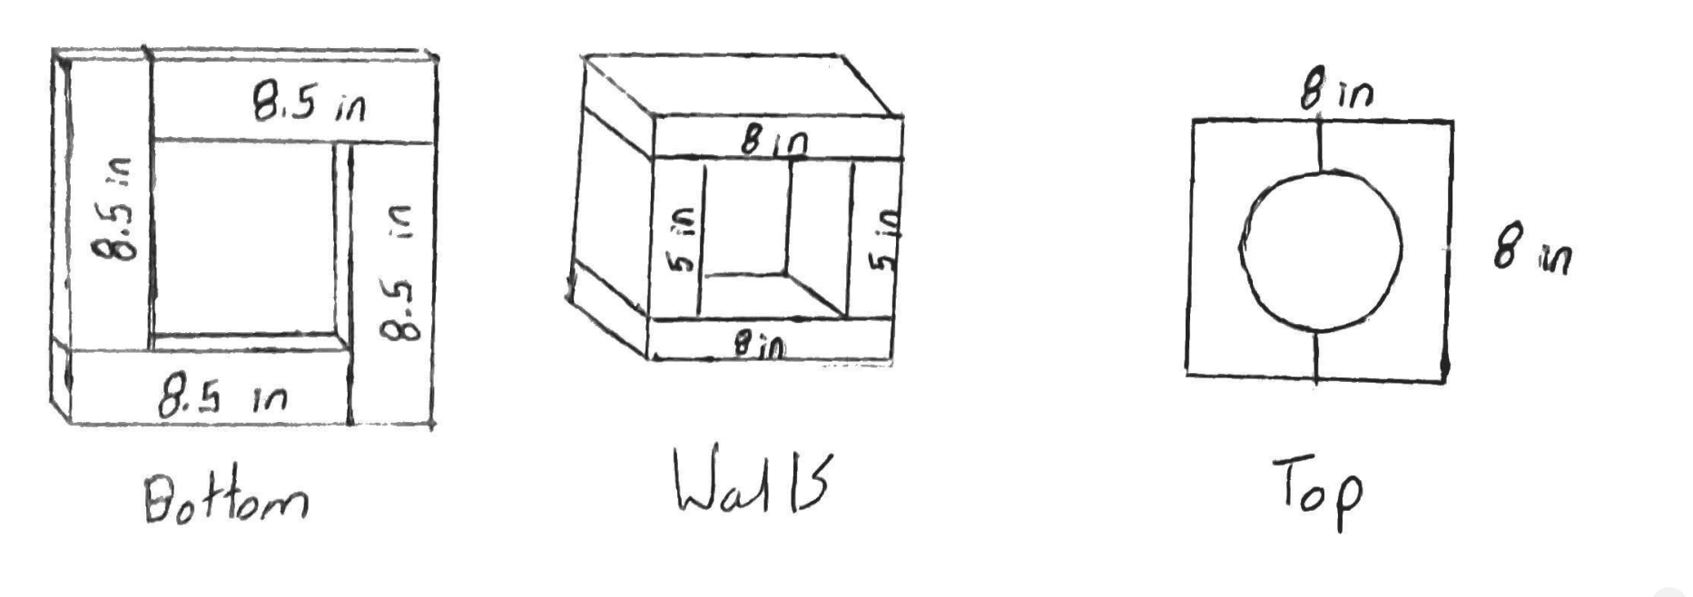

Blower Stand
Wood:
Sizes: Shape
7.5” x 1.5” x 20” (8 x 2 piece) | Rectangle
2x4 | Triangle
2x4 | Trapezoid
*note: You should cut the trapezoid and triangle to the height that supports the height of your blower.

Part Size Number
Galvanized washer | ⅜ “ | 8
Rubber washer | ⅜ “ | 4
Nuts | ⅜ “ | 4
Bolts | ⅜“ * 3- ½ “ | 4
Galvanized Lock Washer | ⅜ “ | 4
Rubber mat | ⅛ “ * 5” * 5” | 1
Deck screws | 2 “ | 5
Air Blower | FJ2- 30C | 1
Rubber coupling | 4” * 4” | 1
4” PVC | 47“ | 1

Basic Instructions
- Place the blower on the ground at a 90 degree angle (pointed up). Line the 8x2 up with the blower. Make sure both are straight up and down. Trace holes in the bottom of the blower onto the wood.
- Drill holes into the wood using a ⅜” drill bit. Put the sheet of rubber in between the blower and the wood.
- Bolt the blower to the wood. The order should be: head of bolt, galvanized washer, rubber washer, plastic blower, wood, galvanized washer, lock washer, nut. (see picture below)
- Now, you need to get your blower standing freely. Add supports to the sides by cutting the 2x4 along a diagonal, standing it up next to the blower, then screwing it on.
- Add the rubber coupling to the output of the blower. You may need to shave off a bit of the plastic to get it perfectly round (so air doesn’t escape through a crack between the flexible coupling and the blower). This can be done with an oscillating multi-tool.
- Put the 47” piece of PVC into the open end of the rubber coupling. Tighten. When you turn on the blower, air should only come out of the end of the PVC.
- An optional feature in the example is the brace on the top of the stand, to make sure the PVC pipe is straight. To do this, take a piece of the discarded plywood, trace a circle onto in with the 4” pipe, and cut it out using a drill and a jig saw. Screw on once completed.
- Prime and paint wood.
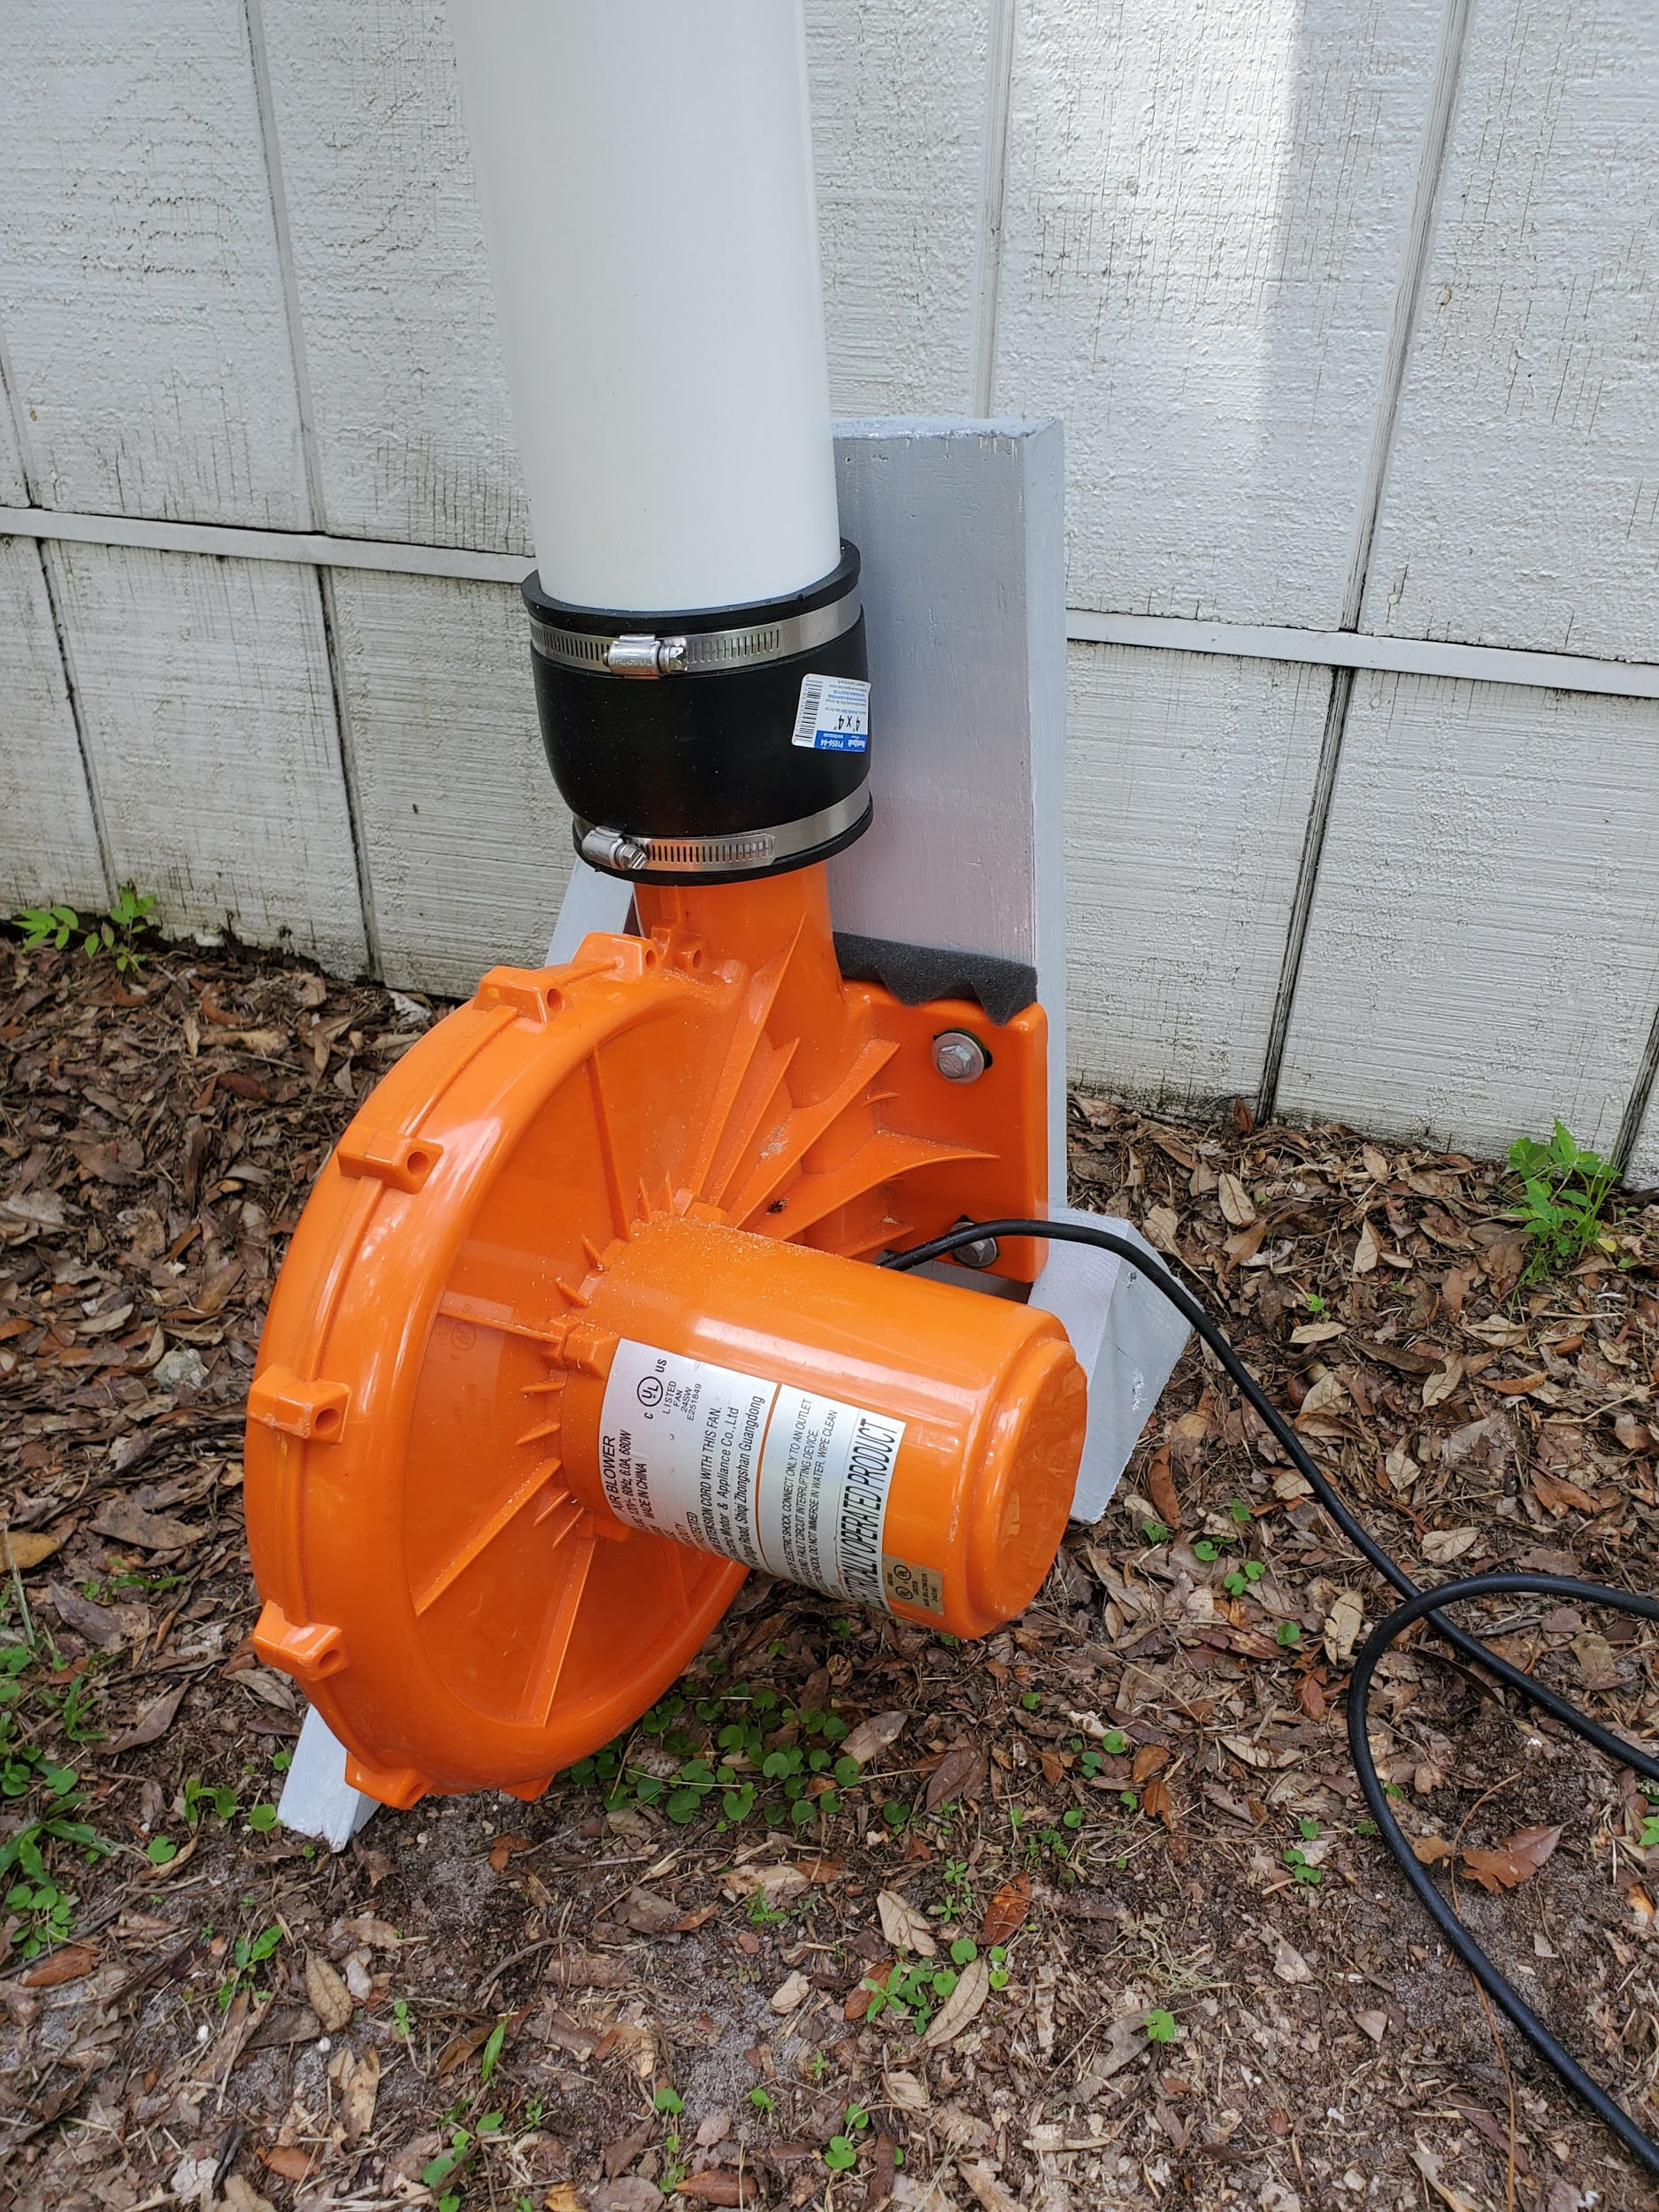
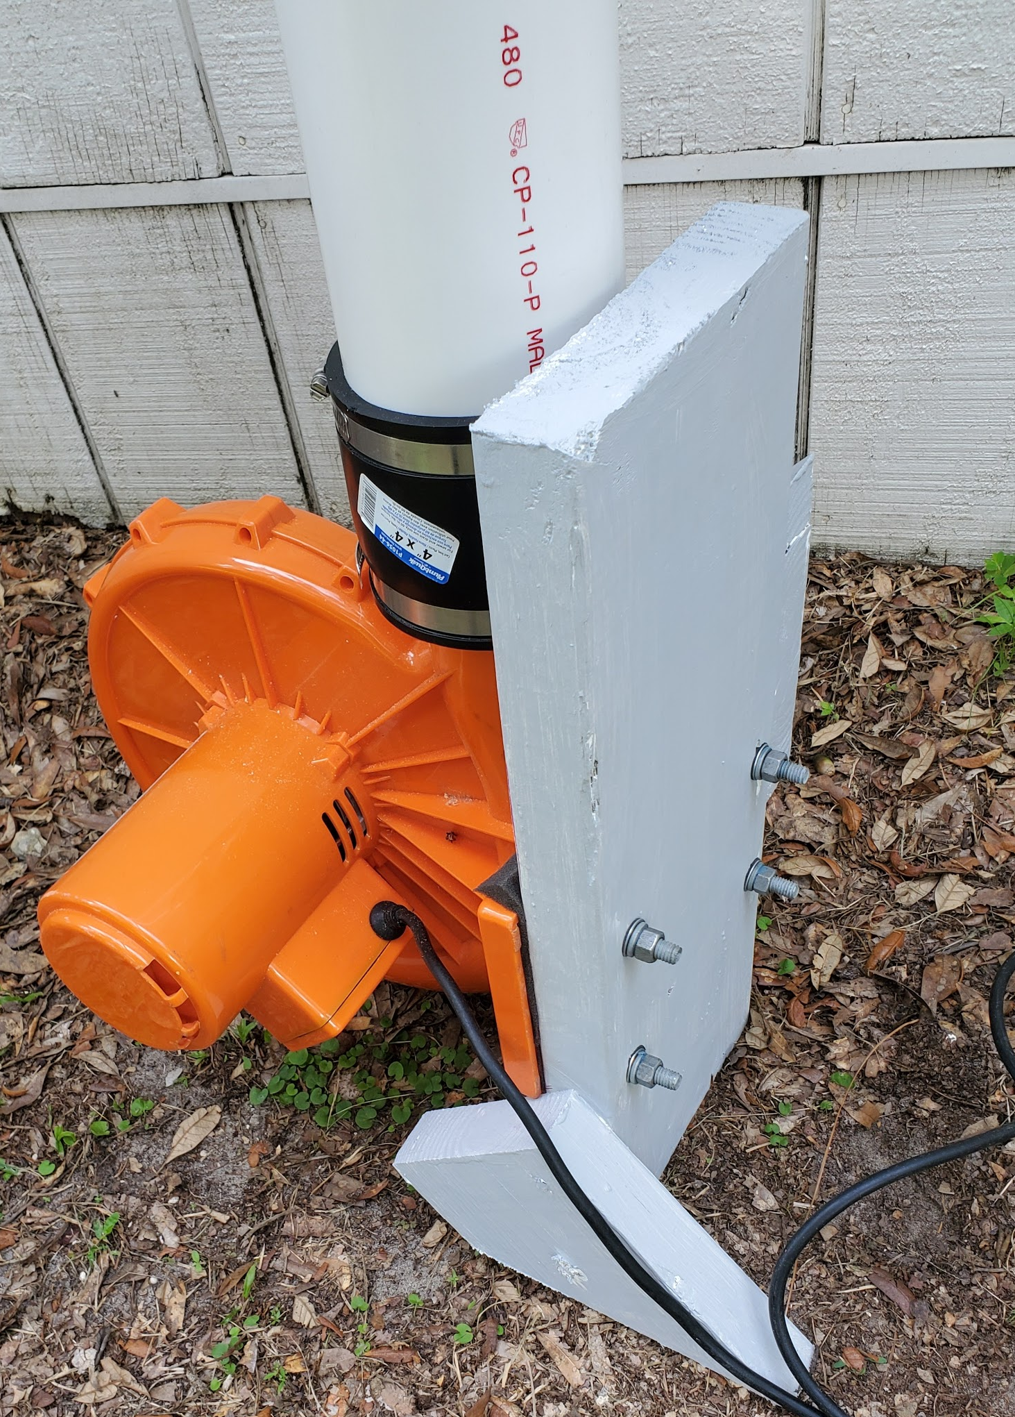

Putting it all together
Place the blower stand and leg 2 (with shoe) on top of the base. Place the top bar on the legs. Glue the hangers in place, facing forwards. Zip tie the hangers to the top bar, 2 zip ties per hanger. Add the extra gear rack to leg 2, gluing in place. Make sure the blower is putting out air at all desired locations.
When you are satisfied with location, screw the blower stand in place. You may want to predrill holes for this step to make it easier. Using 3” deck screws or similar, screw into wood at an angle. Screw shoe into place. Glue the bottom of the extra gear rack into place.

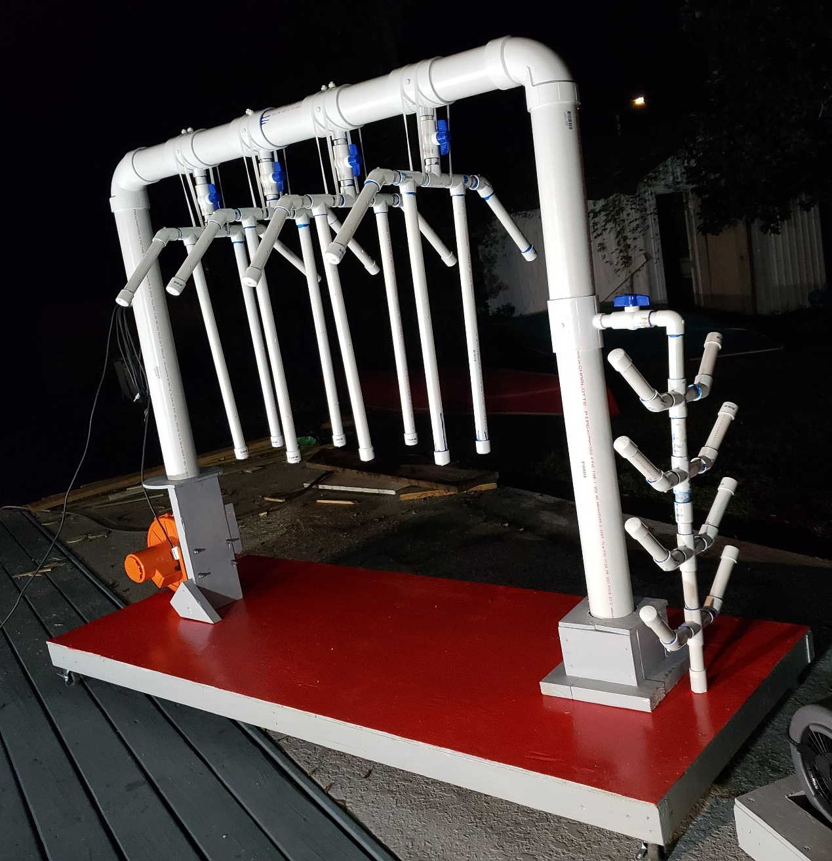

If you have any questions, you can email: pvcgeardryers@gmail.com

